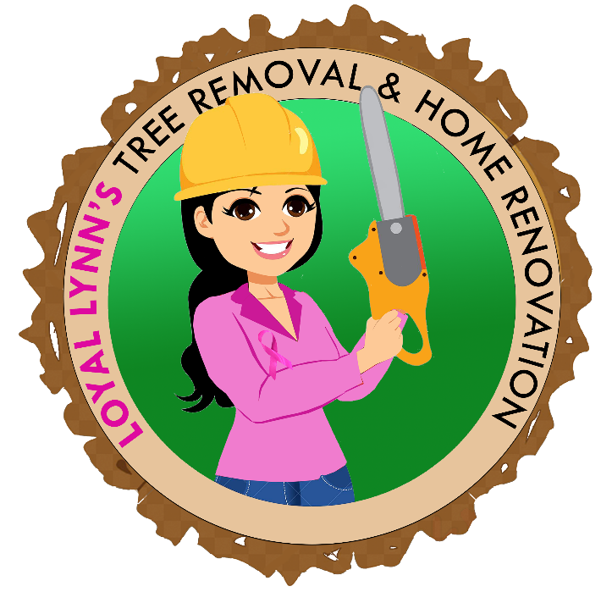
Business Plan
  - LoyalLynnTreeRemoval.com

TABLE OF CONTENTS
Introduction – Page 1
Mission – Page 2
Marketing Plan – Page 3
Contact Us – Page 4

Introduction
Loyal Lynn’s Tree Removal & Home Renovations is a one-stop shop for all of your yard & home improvements. We specialize in Tree Removal. We get rid of dangerous or unwanted trees without destroying your yard no matter the tree size. We have 27 years of experience, that started with Carroll EMC & Greystone! We are Licensed & Insured. We have a trained crew that is well knowledgeable to operate our well-maintained equipment. We give FREE Estimates & provide services 24/7. Our services include:
Tree Removal
Pruning
Storm Damage
Landscaping
Demolition
Retaining Walls
Painting
Power Line/Roof Trimming
Debris Removal & Much more!

MISSION
Loyal Lynn’s Tree Removal & Home Renovation mission is to:

Provide Loyal, Impeccable, & Affordable Service! We promise to remain Reasonable, Reliable, & Reputable! We understand that our target audience is individuals who desire a change in their yard & home, and we will work to give them access of ease to manifest the smallest or biggest dreams of improving their yard space and/or home! Our service stands out from our competitors because we strive to build relationships! Our mission is to serve customers with such a focus and desire that our service will make the tree removal or home improvement and building process enjoyable, exciting, and most importantly successful for everyone. Our belief is that by taking care of our customers and employees while looking after our local communities, we will grow profitably!

MARKETING PLAN
- Our Key Message is “Loyalty”
- Marketing activities: We plan to utilize the following marketing ideas to scale the business
- Media advertising (newspaper, magazine, television, radio)
- Direct mail
- Telephone solicitation
- Seminars or business conferences
- Joint advertising with other companies
- Word of mouth or fixed signage
- Digital marketing such as social media, email marketing, or SEO

CONTACT US
Email: ruizconstruction@gmail.com
Phone: 678.206.7667
Website: www.LoyalLynnsTreeRemoval.com
Facebook: Loyal Lynn’s Tree Removal & Home Renovations
Instagram: @LoyalLynnTreeRemovalLLC .

